MongoDB assignment

1.Connect to a running mongo instance, use a database named mongo_practice.

2.Insert the following documents into a movies collection.

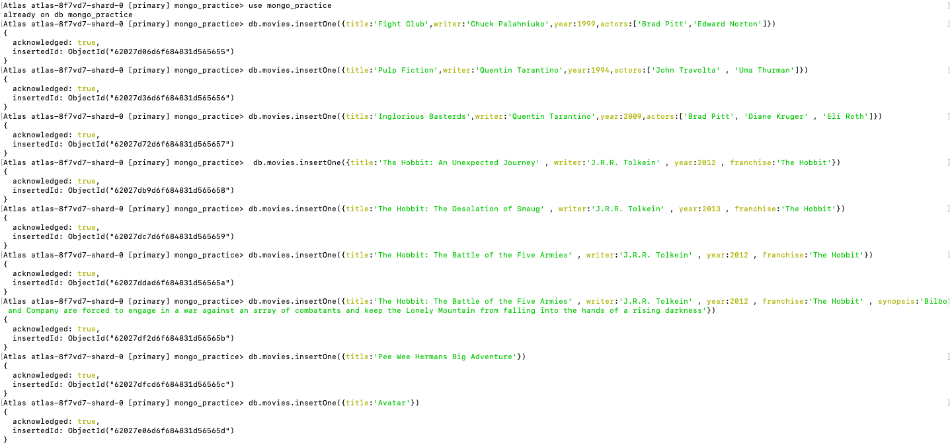

query the movies collection to

1. get all documents

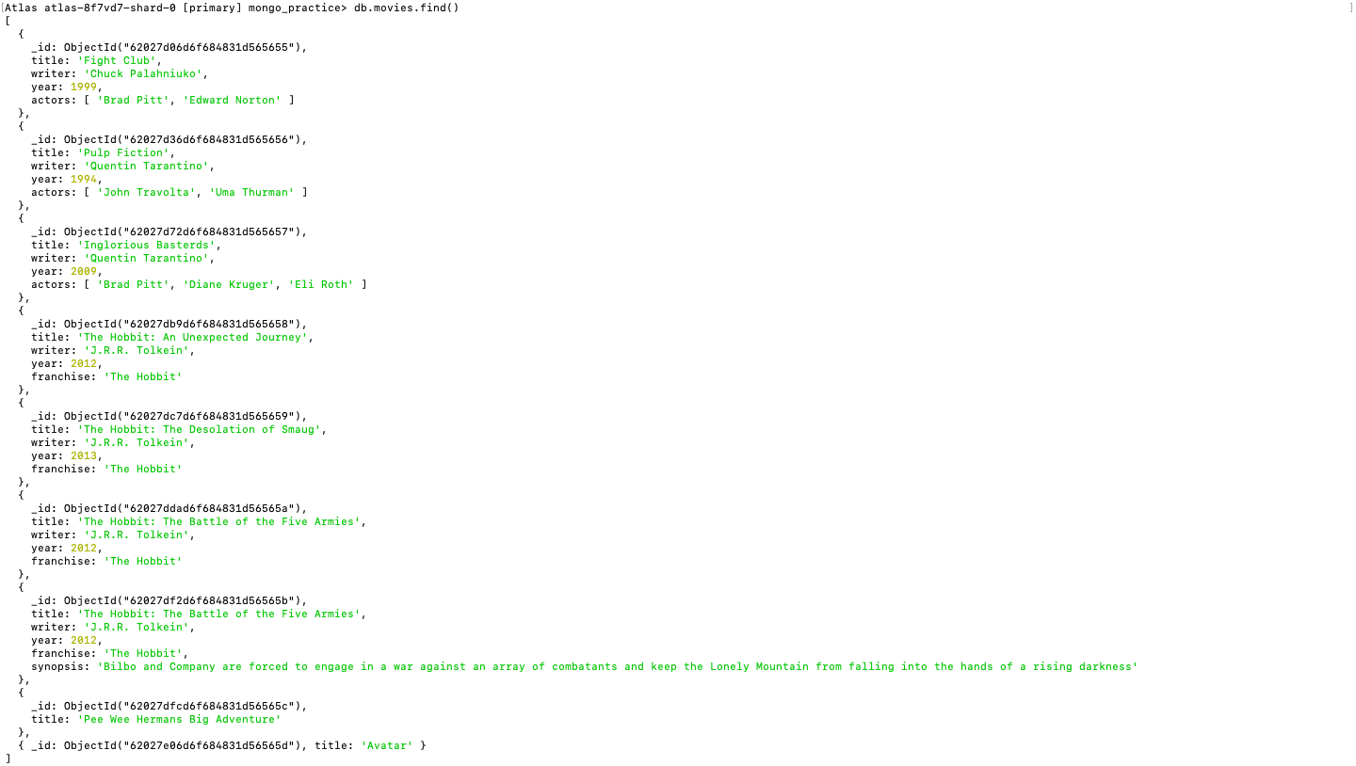

2.get all documents with writer set to "Quentin Tarantino"

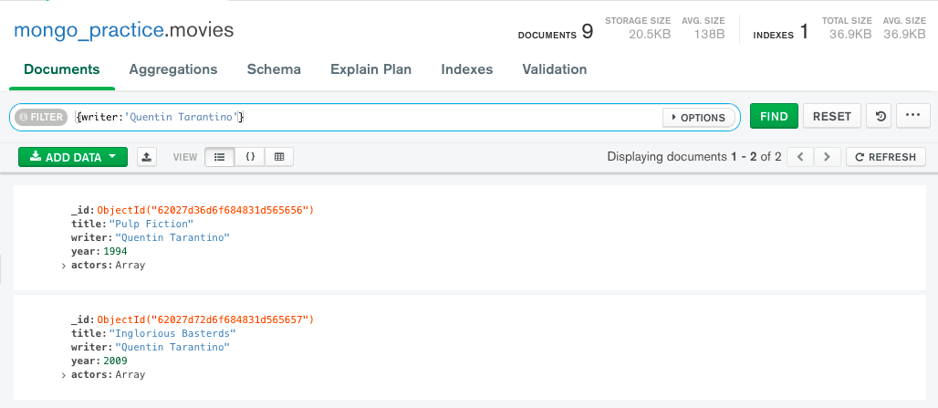

3.get all documents where actors include "Brad Pitt"

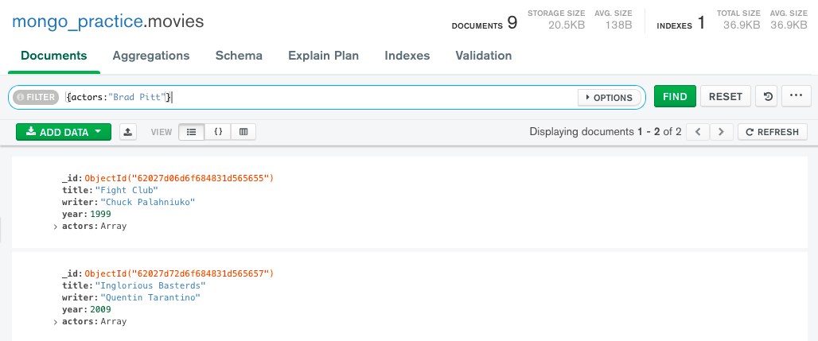

4. get all documents with franchise set to "The Hobbit"

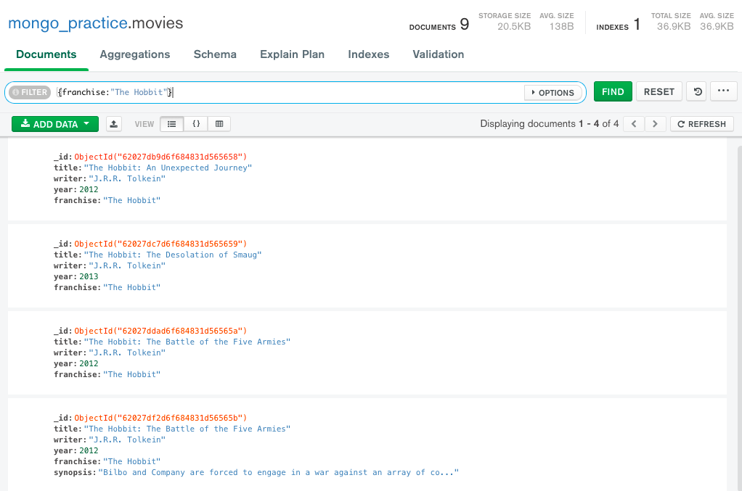

5. get all movies released in the 90s

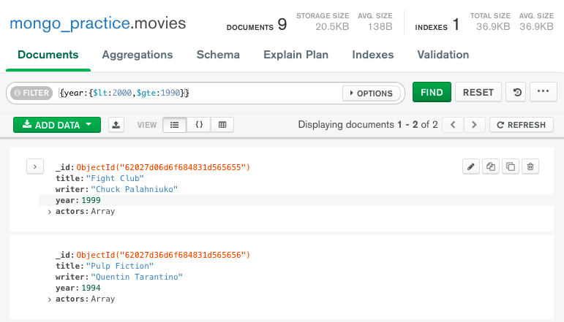

6. get all movies released before the year 2000 or after 2010

